GROCERY STORE RECYCLING
(NOT Eligible for Curb Side Pick Up)
*IMPORTANT: All Items must be Clean and Dry!!
Whole Foods
Accepts a variety of plastic products (as well as corks, glass, cans and paper/cardboard). #5 Plastics, plastic food containers and “clam shell” containers are accepted.
Please note – There are 4 bins for recycle items and they are located in three (3) different areas of the store. (At the Upper Arlington store)
Corks – (natural, no plastic corks) - The bin is located inside the coffee bar/tavern.

Non #5 Plastics (aka Mixed Recycling) - The “bin” is located in the in-store food court area. This is where you would drop off plastic bottles and containers. If you have a large amount, bring it to the Customer Service desk because the bin is a small hole in the counter.

Non #5 Plastics (plastic bags) - The bin is located in the store entrance. It is a green bin tucked in the corner to the left of the Amazon pick-up locker. It is next to the #5 Plastic bin.

#5 Plastics – The bin is located in the store entrance. It is a green bin tucked in the corner to the left of the Amazon pick-up locker. It is next to the green plastic bag bin.
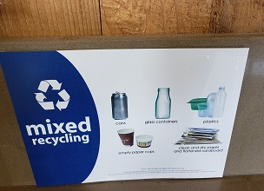
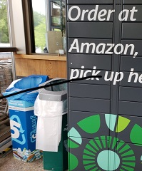

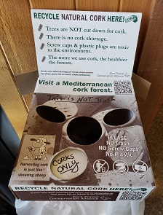

Kroger – The bin is normally located inside the main entrance by the shopping carts

Plastic Shopping Bags
Dry Cleaning Sleeves

Bread Bags
Shrink Wrap

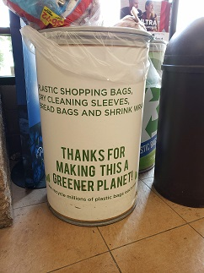

Giant Eagle – The bin is normally located outside one of the store’s entrances

Newspaper Sleeves
Stretch Film Plastic
Plastic Shopping Bags
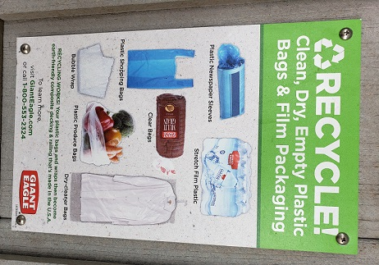
Clear Bags
Plastic Produce Bags
Bubble Wrap
Dry Cleaner Bags

